Appendices - R

Appendix 1 – Interaction Plots
setwd("C:/INSERT FOLDER WITH DATA IN HERE")

library(openxlsx)

Beans<-read.xlsx(xlsxFile="BeanTrial.xlsx","Raw Data")
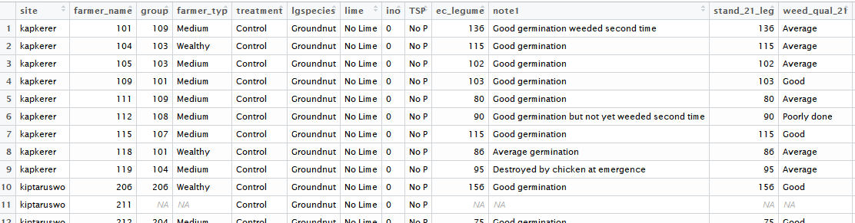
library(ggplot2)

ggplot(data=Beans,aes(y=gyield,x=TSP,group=lime))+
stat_summary(geom="line",aes(col=lime))+facet_wrap(~site)
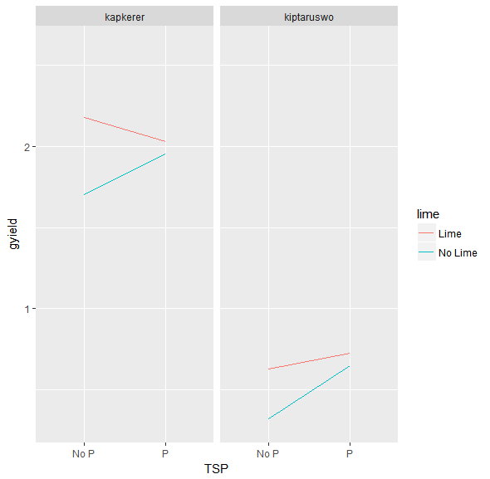

Appendix 2 – Cumulative Risk Plot
setwd("C:/INSERT FOLDER WITH DATA IN HERE")

library(openxlsx)

Beans<-read.xlsx(xlsxFile="BeanTrial.xlsx","Raw Data")

library(RCCRP)

riskdiff(outcome=Beans$gyield,
plotID=Beans$farmer_name,
trtID =Beans$treatment,
trt1="Lime + TSP",
trt2 = "TSP Only")

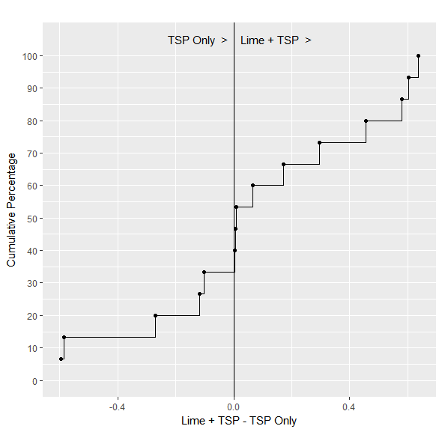

Appendix 3 – Pairwise Treatment Scatterplot
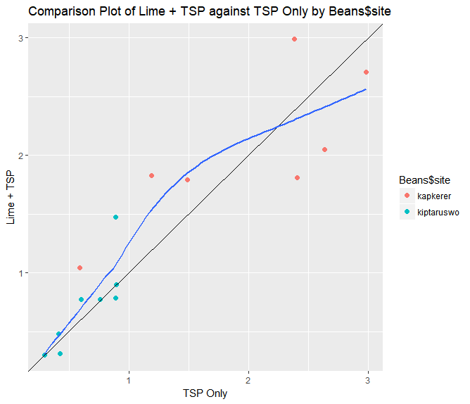
setwd("C:/INSERT FOLDER WITH DATA IN HERE")
library(openxlsx)
library(RCCRP)
Beans<-read.xlsx(xlsxFile="BeanTrial.xlsx","Raw Data")

Producing this plot can be done using the compare_trt() function in the RCCRP library (refer to previous installation instructions). The openxlsx library is also used to read in a data file.

To use the compare_trt() function you need a dataset in long format with one observation for each farmer (or plot) for each treatment. The function has arguments for an outcome variable (e.g. yield), a plotID variable, a treatment ID variable and the names of the two treatments you want to compare.

compare_trt(outcome=Beans$gyield,
plotID=Beans$farmer_name,
trtID =Beans$treatment,
trt1 = "TSP Only",
trt2 = "Lime + TSP",
grpID=Beans$site,
smoother = T)

Appendix 4 – Plots of Yield by Variety by Season
MultiSeason<-read.csv("MultiSeasonTrial.csv")

library(ggplot2)

ggplot(data=MultiSeason,
aes(y=Yield,x=Variety,group=Location))+
geom_point(aes(col=Location))+facet_wrap(~Season)

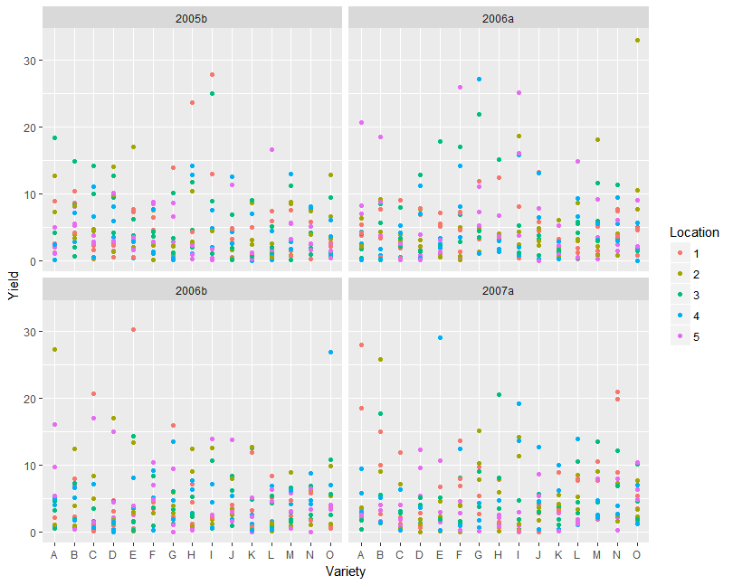

Appendix 5 – Advanced Cumulative Risk Plots
Using the RCCRP library – see Appendix 0 for how to load this into R.

#Read in data set

setwd("C:/INSERT FOLDER WITH DATA IN HERE")
library(openxlsx)

DiffData<-read.xlsx(xlsxFile="GDIFF.xlsx","Raw Data")

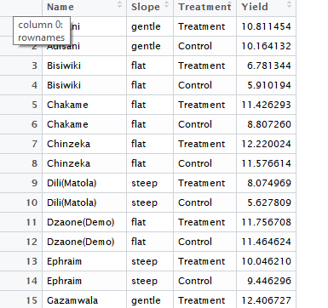

library(RCCRP)

#Overall Plot
riskdiff(outcome = DiffData$Yield,
plotID = DiffData$Name,
trtID = DiffData$Treatment,
trt1 = "Treatment",
trt2 = "Control",
approx = TRUE)
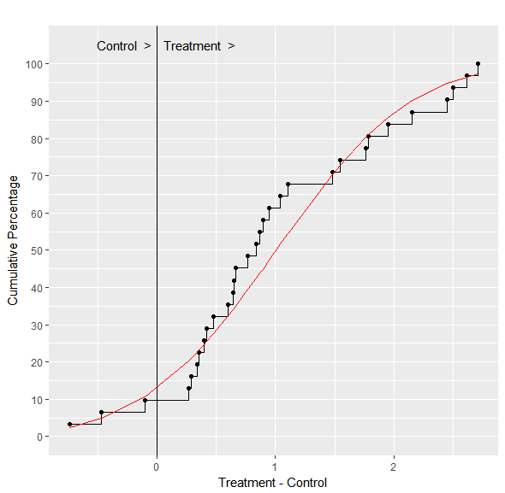
#Split by Slope; Remove the empirical lines and only use the theoretical
riskdiff(outcome=DiffData$Yield,
plotID=DiffData$Name,
trtID = DiffData$Treatment,
trt1 = "Treatment",
trt2 = "Control",
grpID = DiffData$Slope,
approx = TRUE,
emperical=FALSE)
